*Final Report: Financial Interfaces for Behavior Change*

Caroline Berger, Jessica Tsai, Eyimofe Barrow, Alden Brown, Adnan Husain and Shanaya Mullan

ISR 4

December 19, 2021

INST 710

**Research Project Statement**

**Background: Needs for Personal Technologies to Assist in Financial Management**

The US Economy, despite recent setbacks in the past decade exemplified by the 2008 financial crisis and the current COVID-19 pandemic, is recovering and performing well. Data demonstrates that the GDP exceeds its pre-pandemic levels in the second quarter of 2021, with experts exclaiming the GDP is bound to continue to rise. However, there is one common theme that has persevered throughout the years. A significant proportion of Americans are financially unhealthy and routinely adopt poor financial practices in managing their money. The most common issues are poor financial management (e.g. depleting savings) and frequent use of loans and credit lines (e.g. overspending driving credit card debt and high student loan repayments). Americans struggle to meet long-term savings goals and increase their net worth, yet saving for future expenses is a pressing goal. Individuals shy from using paper budgets and instead desire applications that “track everything, [and] use built-in analysis tools” [U.S. Financial Pulse]. Americans require guidance and assistance to manage their finances and budgetary concerns.

Personal financial technologies exist to support spending, saving, borrowing, goal-setting, and financial planning. Bank customers can access online portals and mobile applications to perform basic banking tasks such as checking their balance, depositing checks, and transferring money from account to account. Applications like Mint support users in creating budgets and tracking spending. Mint displays information to assist goal-setting and decision-making surrounding finances. Online and mobile technologies have the potential to improve the financial well-being of individuals through self-tracking and behavioral nudging methods.

**Research Goal: Interfaces for Financial Behavior Change**

Members of the Institute for Systems Research at the University of Maryland requested assistance in the development of a research project aimed at examining the financial health, decisions and behaviors of individuals. To support the long-term goal of the development of an automated coach to nudge users in the direction of meeting their financial goals, our research goal is to examine strategies for interface design for financial behavior change. Within our goal, we address two research questions:

**RQ1:** What mechanism should be used to collect data from undergraduate and graduate students to promote behavior change around financial spending, saving, borrowing, goal setting, and planning?

**RQ2:** What kind of interfaces and forms could automated financial coaches take?

**Methods: Learning from the Experience of Students and Expertise of an Interface Specialist**

We recruited 5 recent and current undergraduate and graduate students from our personal contacts for 30-minute semi-structured remote interviews via Zoom. Members of our research team conducted interviews in October and November 2021. All interviewees are recent or current undergraduate and graduate students in their 20s. Four of our interviewees are women and one interviewee is a man.

Two members of the research team were present at each interview, one member acted as the interviewer and one member acted as the recorder. The semi-structured interviews focused on mobile applications and technology for motivation (both financial and non-financial), financial goals and technologies, and gamification. Participants demonstrated using the technologies they referenced during the interviews (e.g. via screen share) serving as observational data. We iterated our interview questions with small modifications between interview sessions to recalibrate the focus on our research questions and to remove questions we noticed causing participant discomfort [**Appendix A**]. Interviews were audio and video recorded and transcribed using Otter.ai. We de-identified responses from participants and assigned each participant a pseudonym (e.g. P1).

Following each interview, we conducted an interpretation session with at least two additional members who were not present at the interview. The interpretation sessions serve to digest content from the interview and discuss assumptions made by the interview team. We created affinity notes using first-person voices (“I” statements) to contain individual unique ideas grounded in our interpretation sessions.

In addition to our participants, we interviewed Professor Jonathan Lazar, an expert in human-computer interaction, usability and accessibility. We performed an informal thematic analysis for the expert interview to inform the structure of the interview guide and background thought process behind the design decisions for the conceptual designs. We reviewed the themes and corresponding content with our team to ensure all members were grounded in the same expert advice.

*Meetings*

Our team met each week in a working session to advance the project. To ensure alignment, we connected with the other team examining financial decision-making for the Institute for Systems Research. Synching with the other team increased our awareness of preliminary insights to contextualize our interface-focused research. Throughout the project, we discussed the scope of each research project to ensure any overlap in scope was intentional and could continue to produce coherent project updates.

We engaged our client, Dr. Phoel, once every two weeks. We performed a “show and tell” of our progress and received intermittent feedback from Dr. Phoel. The time was an opportunity for the team to ask clarifying questions of Dr. Phoel, and for Dr. Phoel to provide insight and direction for us.

**Analysis: Inductive Models through Contextual Inquiry**

We analyzed data through a contextual inquiry process. We built an affinity diagram by grouping our affinity notes by similarity in content, and used it to create conceptual models. The groups are summarized by a higher order theme, and the grouping and higher order labelling occurs iteratively to form an affinity diagram. The affinity diagram contains themes grounded in layers of lower order themes supported at the base by interview notes.

We synthesized affinity diagrams into experience models to represent the actions, preferences, and feelings of the conglomerate of the interviewees. Each model presents opportunities to satisfy the goals and needs of users. Grounded in the actions, preferences, identities, and feelings of users represented in the experience models, we experimented with design concepts.

We expanded upon the opportunities present in the journey map models in our design concepts; using the experience models as models for interaction, we iterated on the design concepts to increase the likelihood of the designs fulfilling the goals and needs of users. Referencing the affinity diagram, we were able to review details present in the lowest level notes to ensure that we accurately identified needs and that our design suited uncovered needs.

**Outcomes: Issues in Financial Management coupled with Design Solution Ideas**

*Tracking*

Participants used banking applications, Mint, and their own working memory to track incoming money and outgoing spending. Notifications alerted participants when they were overspending in certain areas of their lives, and in the converse, on payday. At times, categories were incorrect consequently requiring the participant to manually revise the categorization or to take a mental note of the true budget values.

*“I like mint… every time I get paid, [Mint] sends me notifications like whoo payday. That's fun.” (P4)*

*“So Mint is typically where I check my spending, mostly. But I'd say that sometimes… Mint has its own categorization of your charges that you've made, and sometimes they just get them wrong. Like sometimes it categorizes a charge into like restaurants or just Western restaurants. I find that frustrating sometimes. So I'd say that lately, I have been swaying a little bit back towards my banking apps just to very easily check my spending, because I do think that banking apps do a little bit better job at categorizing my expenses.” (P4)*

*“I need to get better at [tracking spending]. But usually, one thing that kind of helps me just sort of like, the big thing for me is I spend too much money on drinks and like alcohol and chocolate going to Starbucks and [stuff] like that… But for me, I kind of just keep track of this, or at least like kind of like slap myself on the resume because I get like notifications for any time, like my credit or debit card is used.” (P2)*

Design idea

In-depth transaction histories made personalizable could replace the mental load to track expenses in working memory. Individuals should be able to customize categorization and notifications to receive updates on their outgoing and incoming transactions.

*Self-imposed controls*

Interviewees imposed constraints to their own financial behaviors. To limit spending, one participant set a credit card limit on their account that was lower than their actual credit card limit. Similarly, a participant leveraged Mint to set budgeting limits. Another participant transfered money from their checking account to their savings account to prevent spending and increase saving. Instead of using cash, another participant carried only electronic forms of payment and credit card to limit the temptation to spend.

*“So the good thing about the reason why I've set the credit limit so low is so that I don't really overspend in a short period of time. It keeps me grounded, so to speak… I usually think about it in cycles, there is my first 10 days or first 15 days, $300 is what I try to go through. And then the next 15 days, another $300.” (P5)*

*“Every single month out of your paycheck take like $100 out, and just don't touch it…I use my banking account… to transfer that money into my savings, because it automatically goes into my checking account.” (P4)*

Design idea

Encouragement and rewards for limiting spending and increasing saving is a promising feature in future financial coaching technologies.

*Goal-setting*

Participants noted the importance of setting financial goals, yet found the process challenging. Preferring goals that are categorized, time-bound, realistic, and measurable, participants expressed goal-setting as a motivating tool for changing their saving and spending behaviors. A participant commented that overly aggressive saving goals led to feelings of deprivation. Financial goals must balance long-term saving with short-term enjoyment.

*“The biggest challenge I face is when I first started setting my goals, I was really unrealistic, they’d be way too low. And I wouldn't be able to give myself kind of like the pleasures of like, if I work really hard one week, I wouldn't be able to kind of give myself a treat or whatever, because my goal was too low. But now I'm trying to work on that.” (P3)*

*“I don’t have a specific monetary goal in terms of ‘I want to save this amount of money’. But I do set budget limits for myself in terms of food, groceries, just kind of miscellaneous fun expenses.” (P4)*

*“I guess with some of my financial goals, I haven't really made clear a date set for myself of what I want to and that's something I definitely want to do in the future. I feel like when I was starting my job, I've had kind of a big transition, like from being undergrad to starting a job. So I think moving forward, I want to have more concrete financial goals and set them to a date that I want to meet them by because mine was kind of just like in general.” (P1)*

Design idea

Goal progress portrayed as a scale as opposed to a binary (i.e. achieved, not achieved) is a promising motivation tool to encourage incremental and partial success.

*Financial information-seeking*

The sources and methods in which interviewees learned about finances varied from family members to internet resources. A participant struggled to articulate questions to query in search engines. Family advice left the information-seeker unsatisfied and searching for advice on spending, saving, planning and goal setting, and not simply advice on saving.

*“I'd say that would be really helpful. Because, I just feel like there isn't a lot of centralized stuff about finances right now. You really just have to kind of throw yourself out there and find something. So if there was an app already, that you're using for budgeting, and then also have information in there. That would be really helpful.” (P4)*

*“I don't think I have a person in my life that gives me financial advice, except for my parents, who just throw random things like ‘make sure you're not spending too much money,’ which isn't, I don't really say financial advice.” (P4)*

Design idea

Communal advice spaces reduce the need to articulate questions by supporting browsing through a database of already answered questions. A centralized location of financial topics encourages financial learning and facilitates the discovery of information.

*Interaction styles and interface design*

Participants preferred classic keyboard and mouse input interactions for desktop or tap-touch input interactions for mobile. Participants did not like using chatbots and voice assistants. Interfaces must be captivating to retain the attention of users to facilitate long term application necessary for behavior change.

*“I've had this watch for like four years now. And I kind of don't even look at it anymore. Yeah, kind of the novelty kind of just [wore off], the exact same thing over and over again. Little notifications, icons, nothing is catching my eye anymore.” (P3)*

*“I feel like I stick to things a lot better when it's like in a class setting, like by myself , I feel like in the past, I've used that meditation app. I don't really remember what it's called. But I only stick to it for a week, I just cannot focus on meditation. On apps. I don't know why I feel like I need to be in a class.” (P1)*

*“Yeah, I'd say I'm definitely a visual person. So anything that has like, I don't know, I guess I do like circles. So anything with like, a completion circle or like, something like that? Because it can really show me how close I could be to my goal, like how close I am? And how I'm almost there. So I may as well complete it. As opposed to just seeing raw numbers and data doesn't really connect with me.” (P4)*

Design idea

Interfaces must be captivating with a simple user interface to engage and delight individuals.

**Product Concepts**

To address the issues faced by participants and to depict design solution suggestions, we designed two product concepts.

*Ask questions and reach your financial goals: Product Concept #1*

Our first design concept addresses budgeting, the tracking of spending, goal-setting, educational resources for financial education, and a communal element for discourse on finances.

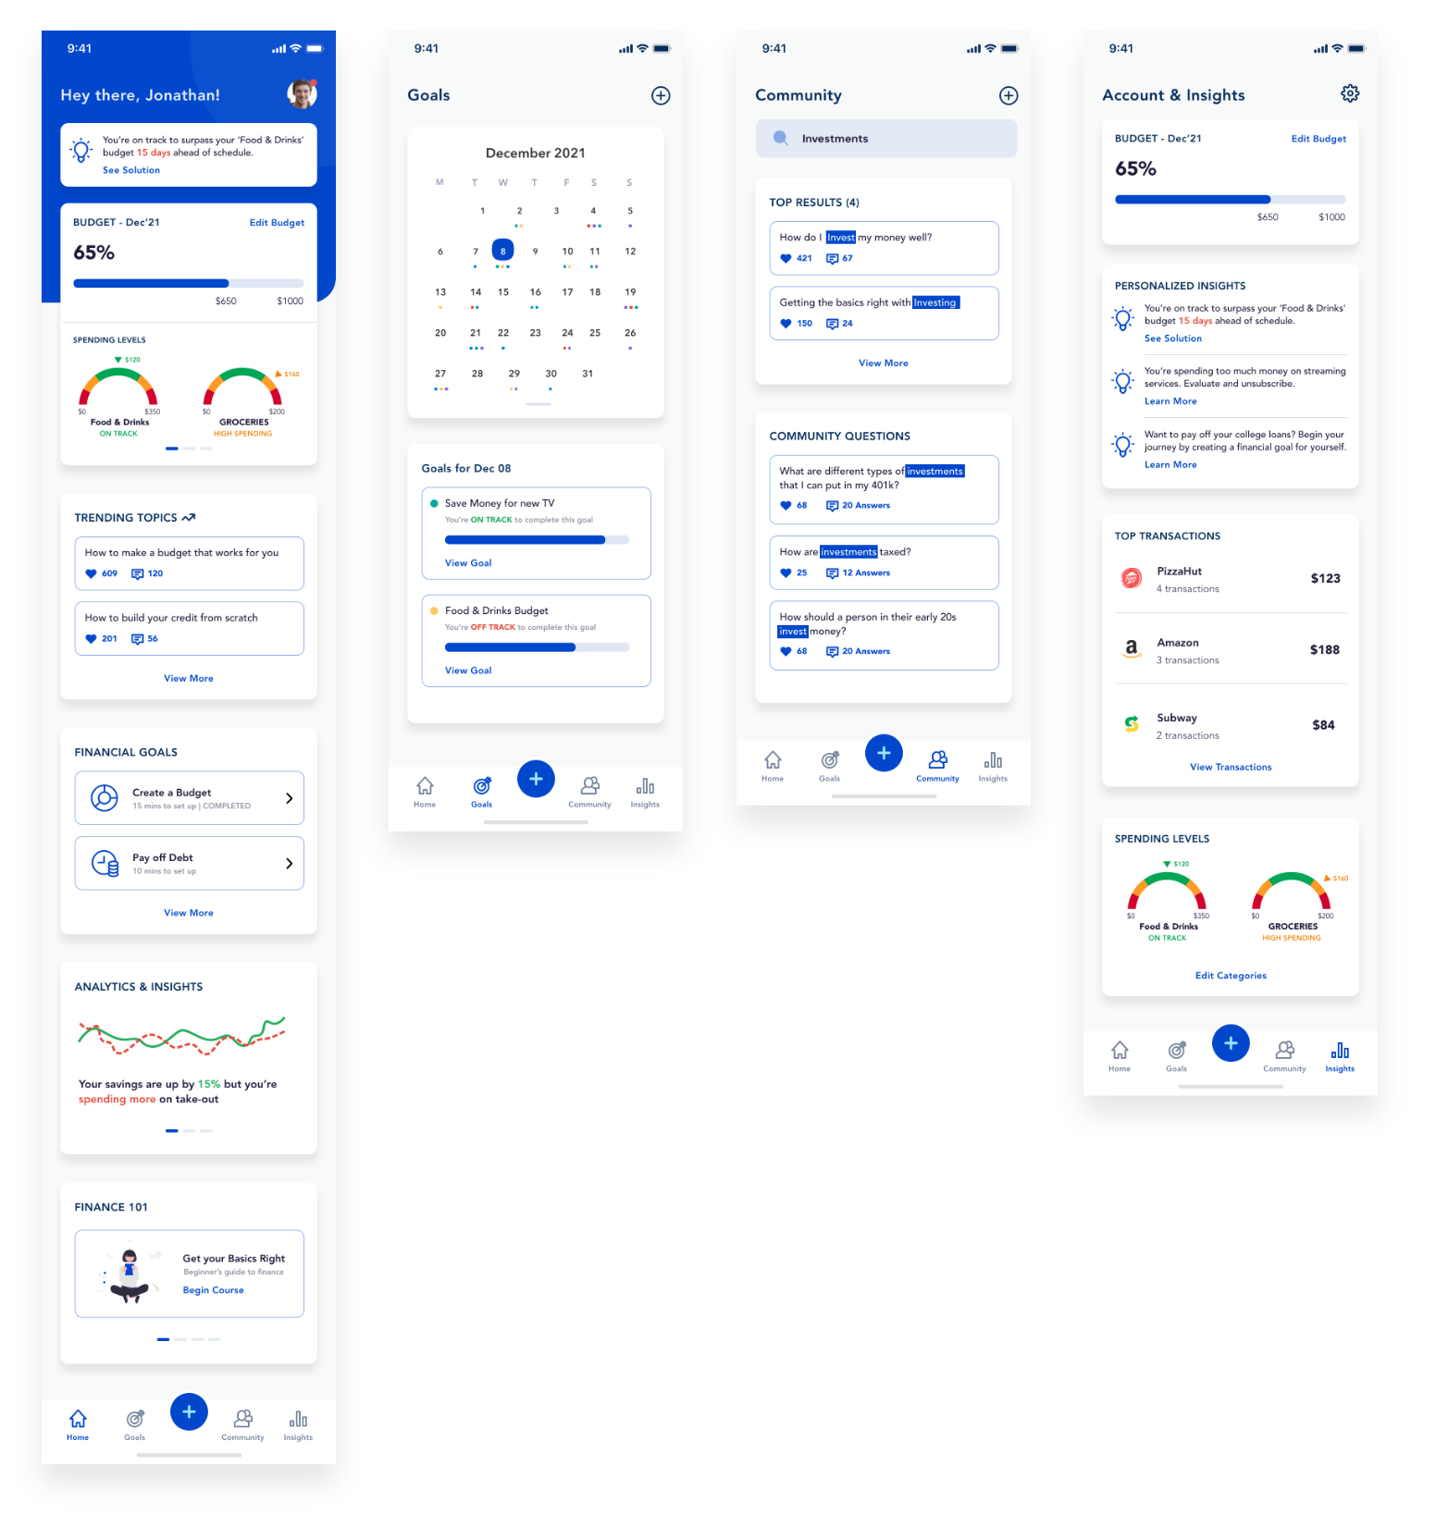

**Figure 1: Product Concept #1 Overview of financial education interface ideas**

Goals are time-bound and reflected on a calendar.

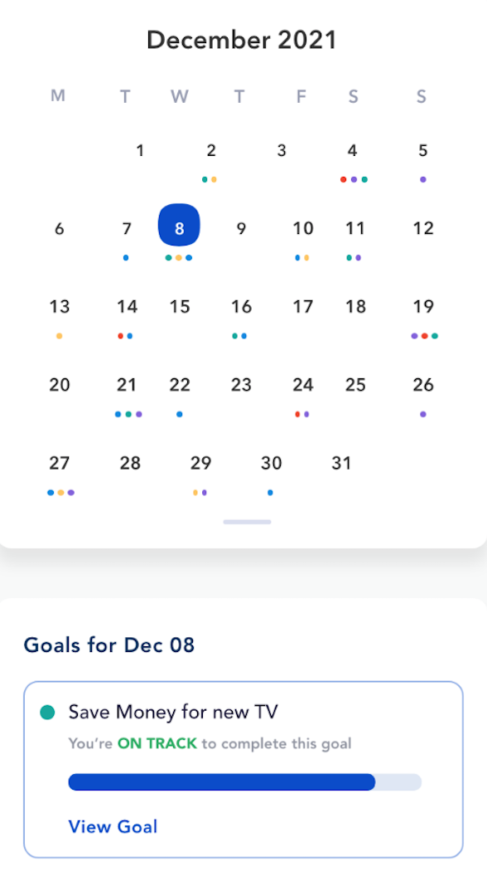

**Figure 2: Product Design Concept #1, Calendar feature**

To harmonize current enjoyment and long term financial well being, spending is depicted on a gauge

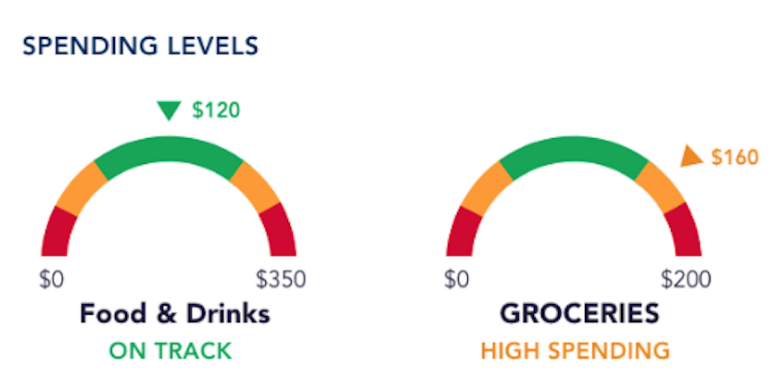

**Figure 3: Product Concept Design #1, Gauge representing spending levels feature**

Information-seekers can browse questions and answers and contribute to the forum resulting in a space for people in similar situations to engage in open dialogue and learn from one another.

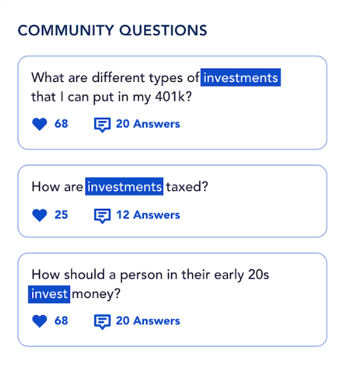

**Figure 4: Product Design Concept #1, Community forum feature.**

*Financial Game of Life: Product Concept #2*

Our second design uses gamification to confront the player with challenging financial situations that require the player to make difficult financial decisions, such as deciding how to adjust your budget after an unforeseen expense (e.g. popped tires, car accidents, etc.). Players learn the consequences of possible decisions through the game preparing the player for real life mishaps. Financial education material is present at each level to encourage additional learning throughout the game.

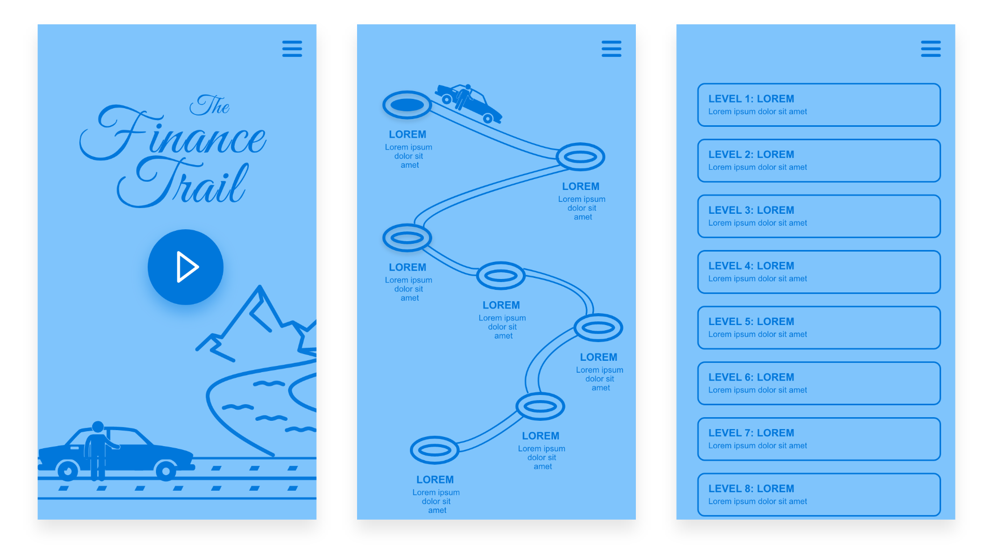

**Figure 5: Product Concept #2 Overview of gamification interface ideas**

**Appendix A: Interview Guide**

Interview Guide

*We should keep in mind:*

* *The final interactive product doesn’t have to be a game, we want to infer what type of interface would a user find most helpful to meet a goal*
* *We need to identify pain points*
* *Move from abstract to concrete retrospective accounts*

*What we want to know:*

* *What mode of interaction works best?*
* *Game or would something else work better?*
* *How do we accurately capture or simulate financial decision making?*
* *How do grad students differ from other populations when it comes to financial decision making?*

Thank you for letting us interview you, we will be sure not to take up too much of your time.

We will be asking you questions related to your financial decisions, as well as tools you use to help you meet your goals.

Your responses and identity will be kept confidential, they will not be disclosed to any other parties.

You are free to skip any questions if you feel uncomfortable to answer any or don’t want to answer in general too.

Is it ok if we record this session?

1. Can you tell me about a goal you had and if you used technology to aid you in accomplishing it?
2. When was the last time you set a financial goal for yourself? Did you meet it, and what was your approach?
   1. How do you typically pay for things?
   2. How do you track your spending?
   3. Where do you go for financial advice? Do you talk to someone or do you use some kind of resource
   4. Can you walk me through a challenge you had setting financial goals?
   5. How do you manage college loans? (Only if they mention college loans as a challenge)
3. Can you tell me about how you used technology to reach the goal?
   1. Do you use any banking apps?
   2. Have you used any learning apps? Were they useful?
   3. Do you use any mindfulness apps? Can you tell me about this?
   4. Do you use any health apps?
   5. Reason for discontinuing use of such apps (if any) - Please elaborate?
   6. Can you tell me about the last time a technology changed your mind about something?
4. How else have you used technology in relation to personal finance (others)?
   1. Websites?
   2. Can you tell me the last time you used a chat bot? Was the experience useful and did you accomplish your goal?
5. Do you play any games?
   1. Have you used any apps which feature gamification and achievements?
   2. Do you play board games?
   3. Do you play online games with other people?
   4. Do you find games to be an effective motivation tool? For example, duolingo, and fitness apps.